 Mini LED Spot Light

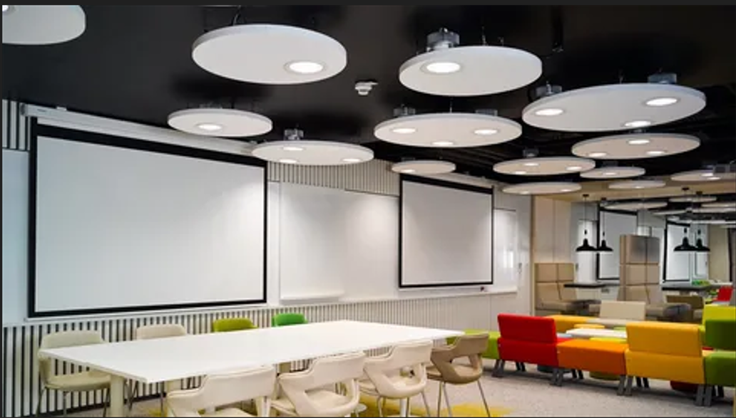

#### ****Description:****

**Mini LED Spot Lights** are compact, energy-efficient lighting solutions designed to provide focused and directional light for small spaces. These lights are perfect for highlighting specific areas or objects, such as artwork, shelves, or retail displays. With a sleek and modern design, Mini LED Spot Lights offer both functionality and style.

* **Technology:** LED.
* **Compatibility:** Standard E26/E27 base (fits most fixtures).
* **Bulb Type:** Integrated LED (non-replaceable).
* **Wattage:** 3W (equivalent to 25W incandescent), 5W (equivalent to 40W incandescent).
* **Lumens:** 250 lumens (3W), 400 lumens (5W).
* **Color Temperature:** 2700K (warm white), 3000K (soft white), 4000K (cool white).
* **Dimmable:** Yes (select models).
* **Lifespan:** 25,000 hours.
* **Energy Efficiency:** Energy Star certified.
* **Beam Angle:** Adjustable (typically 15° to 60°).

#### ****Key Features:****

* **Compact Design:** Small and lightweight, ideal for tight spaces.
* **Energy-Efficient:** Uses up to 85% less energy than traditional incandescent bulbs.
* **Focused Lighting:** Ideal for highlighting artwork, shelves, or retail displays.
* **Dimmable Options:** Available in dimmable models for adjustable brightness.
* **Long Lifespan:** Lasts up to 25,000 hours, reducing the need for frequent replacements.
* **Adjustable Heads:** Allows you to direct light precisely where it’s needed.
* **Easy Installation:** Designed for simple mounting with included hardware.

#### ****Pricing:****

* **Single Mini Spotlight (3W):** $14.99
* **Single Mini Spotlight (5W):** $19.99
* **4-Pack (3W):** 49.99(49.99(12.50 per light)
* **4-Pack (5W):** 69.99(69.99(17.50 per light)

#### ****Where to Use:****

* **Art Galleries:** Highlight artwork with precise, focused lighting.
* **Retail Stores:** Showcase products with bright, adjustable spotlights.
* **Living Rooms:** Accentuate decor or architectural features.
* **Kitchens:** Provide task lighting for countertops and workspaces.
* **Shelves:** Illuminate books, collectibles, or decorative items.

### ****Customer Reviews:****

* ⭐⭐⭐⭐⭐ "These Mini LED Spot Lights are fantastic! They provide bright, focused light, and the adjustable heads make it easy to direct the light exactly where I need it." – Sarah L.
* ⭐⭐⭐⭐ "Great value for the price. The lights are bright, and the dimming feature is smooth and reliable. Highly recommend for anyone looking to upgrade their lighting." – James T.
* ⭐⭐⭐⭐⭐ "I love how energy-efficient these spotlights are. The compact design is perfect for my shelves and artwork." – Emily R.

### ****How to Order:****

1. Visit our website: [www.brightworldlighting.com](http://www.brightworldlighting.com/)
2. Select your preferred spotlight type and pack size (Single or 4-Pack).
3. Add to cart and proceed to checkout.
4. Enjoy free shipping on all orders over $50!

### ****Warranty and Support:****

* **Warranty:** 2-year limited warranty covering manufacturing defects.
* **Customer Support:** Contact us at [support@brightworldlighting.com](mailto:support@brightworldlighting.com) or call +1-800-123-4567 for assistance.

### ****Visual Representation:****

Include high-quality images of the Mini LED Spot Lights in different settings (e.g., art gallery, retail store) to showcase their versatility and design.